

MACHINE LEARNING MODEL FOR PREDICTING NEONATAL READMISSION. A CASE STUDY OF MUKONO GENERAL HOSPITAL

SSENFUMA RONNIE
REG No: 2024/HD07/22318U

A DISSERTATION SUBMITTED TO MAKERERE UNIVERSITY
SCHOOL OF PUBLIC HEALTH IN PARTIAL FULFILMENT
OF THE REQUIREMENTS FOR THE AWARD OF THE
DEGREE OF MASTER OF HEALTH INFORMATICS

Approval
This dissertation has been submitted for examination with the approval of the following supervisors:
Dr. Vincent Michael Kiberu
Makerere University School of Public Health
Department of Epidemiology and Biostatistics
Email: vkiberu@musph.ac.ug
Tel: +256 701 431 524
Date: 12th January 2026

Declaration

I, Ssenfuma Ronnie, declare that this dissertation titled “Machine Learning Model for Predicting Neonatal Readmission. A Case Study of Mukono General Hospital” is my original work and has not been submitted to any university or institution of higher learning for any academic award. Where other works have been cited, due acknowledgment has been made.
__________________________
Ssenfuma Ronnie
Date: ___________________________

Dedication
I dedicate this dissertation to Almighty God for His guidance and strength throughout my academic journey. I also dedicate this work to my family for their continuous support, encouragement, and sacrifices, and to the healthcare workers committed to improving neonatal healthcare outcomes in Uganda.

Acknowledgements
I would like to express my sincere gratitude to Almighty God for granting me the strength, wisdom, guidance, and good health throughout the course of this study and my academic journey. His grace and blessings enabled me to successfully complete this dissertation.

I extend my deepest appreciation to my supervisor, Dr. Vincent Michael Kiberu, for his invaluable guidance, continuous support, constructive criticism, and professional mentorship throughout the development of this dissertation. His expertise, encouragement, and commitment greatly contributed to the successful completion of this research work.

I also wish to acknowledge the Makerere University School of Public Health, particularly the Department of Epidemiology and Biostatistics, for providing me with the academic knowledge, learning environment, and institutional support necessary for conducting this study. Special appreciation goes to all lecturers and academic staff whose dedication and guidance have shaped my professional and research skills during the Master of Health Informatics program.

My sincere appreciation goes to the management and staff of Mukono General Hospital for granting permission to conduct this study and for their cooperation during data collection. I am especially grateful to the records staff and healthcare workers who provided support and facilitated access to the required hospital data and records.

Finally, I would like to thank my family, friends, classmates, and all those who offered moral support, encouragement, prayers, and motivation throughout my studies. Your support and belief in me played a significant role in the successful completion of this dissertation.

Table of Contents
Approval i
Declaration ii
Table of Contents iii
Operational Definitions vi
Abstract viii
CHAPTER ONE 1
1.0 Introduction 1
CHAPTER TWO 4
LITERATURE REVIEW 4
2.1 Introduction 4
2.2 Neonatal Readmission overview and burden 4
2.3 Determinants and challenges for neonatal readmission 5
2.4 Critical analysis of current risk prediction approaches 5
2.5 Machine learning and performance metrics in clinical informatics 6
2.8 Research Gap 7
CHAPTER THREE ……………………………………………………………………………9
3.0 STATEMENT OF THE PROBLEM, JUSTIFICATION, CONCEPTUAL FRAMEWORK 9
3.1 Statement of the Problem 9
3.2 Justification 10
3.3 Conceptual Framework 11
CHAPTER FOUR………………………………………………………………………………13
4.1 Research Questions 13
4.2 General Objective 13
CHAPTER FIVE………………………………………………………………………………14
METHODOLOGY……………………………………………………………………………..14
5.1 Introduction 14
5.3 Study population 14
5.4 Research Design 14
5.5 Sample Size Determination 15
5.6 Sampling procedure 15
5.8 Data Collection 17
5.8.1 Data Collection Procedure 17
5.8.2 Data Collection Tools 17
5.8.3 Pre-testing of Tools 18
5.8.4 Field Editing of Data 18
5.8.5 Handling Missing Data 18
5.9 Data Management and Analysis 18
5.10 Prototype system design (Clinical Decision Support System) 20
References...………………………………………………………….…………………………..21
Appendix A: 26

Acronyms and Abbreviations
Abbreviation | Meaning
AI | Artificial Intelligence
ANC | Antenatal care
AUC | Area Under the Curve
AUC-ROC | Area Under the Receiver Operating Characteristic Curve
CDSS | Clinical Decision Support System
CS | Caesarean Section
EBF | Exclusive Breastfeeding
EPV | Events per Variable
F1-Score | Harmonic Mean of Precision and Recall
GA | Gestational Age
HDREC | Higher Degrees Research and Ethics Committee
HIS | Health Information System
KNN | K-Nearest Neighbors
LMICs | Low- and Middle Income Countries
MGH | Mukono General Hospital
NVD | Normal Vaginal Delivery
Python | High level programming Language for data science and machine learning
RDS | Respiratory Distress Syndrome
ROC | Receiver Operating Characteristic
SMOTE | Synthetic Minority Over sampling Technique
SOPs | Standard Operating Procedures
DT | Decision Tree
EHR | Electronic Health Record
HICs | High Income Countries
IRD | Institutional Review Board
LR | Logistic Regression
ML | Machine Learning
MOH | Ministry of Health
NTISS | Neonatal Therapeutic Intervention Scoring System
PU | Perceived usefulness
RF | Random Forest
RMNCAH | Reproductive, Maternal, Newborn, Child, and Adolescent Health
SDG | Sustainable Development Goal
SHAP | Shapley Additive Explanations
SVM | Support Vector Machine
TRIPOD | Transparent Reporting of a Multivariable Prediction Model for Individual Prognosis of Diagnosis
UBOS | Uganda Bureau of Statistics
UDHS | Uganda Demographic and Health Survey
UNICEF | United Nations Children’s Fund,
WHO | World Health Organization

Operational Definitions
Gestational Age (GA)- The estimated age of the neonate at birth, recorded in completed weeks, as documented in the patient’s medical file (derived from Last Menstrual Period or early ultrasound), used as a key clinical predictor of neonatal risk.
Machine Learning (ML)- A subfield of Artificial Intelligence utilizing classification algorithms (e.g., Random Forest, Logistic Regression) to automatically identify non-linear patterns within the historical clinical data to generate predictions(Jordan, 2015).
Clinical Decision Support System (CDSS) - This refers to a computer-based tool designed to assist healthcare providers in clinical decision-making by providing data-driven recommendations or predictions. In this study, the prototype CDSS demonstrates how machine learning predictions can support neonatal discharge decision-making.
Neonatal Readmission- The unplanned re-hospitalization of a newborn at Mukono General Hospital within the 28-day window following the initial discharge, serving as the binary dependent variable (1 = Readmitted, 0 = Not Readmitted) for this study(Smith, 2022).
Maternal Factors-Maternal factors refer to characteristics related to the mother that may influence neonatal outcomes. In this study, maternal factors include maternal age, parity, antenatal care attendance, mode of delivery, and maternal medical conditions.
Neonatal Factors - Neonatal factors refer to characteristics related to the newborn that may influence the risk of readmission. These include birth weight, gestational age, Apgar score, feeding type, and neonatal complications during the initial admission.
Readmission Risk Prediction - Readmission risk prediction refers to the process of estimating the likelihood that a neonate will be readmitted after discharge using machine learning algorithms trained on historical clinical data.
Data Preprocessing - This refers to the procedures performed to prepare raw data for analysis and machine learning modeling. These procedures include data cleaning, handling missing values, encoding categorical variables, normalization, and removal of inconsistencies.
K-Nearest Neighbors (KNN) Imputation- This is a data imputation technique that estimates missing values using similarities between observations in the dataset. In this study, KNN imputation is used to handle missing clinical data.
Synthetic Minority Over-sampling Technique (SMOTE) - This is a machine learning method used to address class imbalance by generating synthetic examples of the minority class. In this study, SMOTE is used to improve model learning for neonatal readmission cases.
Logistic Regression - This is a supervised machine learning algorithm used for binary classification problems. In this study, it is used as a baseline model for predicting neonatal readmission.
Random Forest- This is an ensemble machine learning algorithm that combines multiple decision trees to improve prediction accuracy and reduce overfitting.
In this study, Random Forest is used to model complex relationships between predictor variables and neonatal readmission.
Support Vector Machine (SVM) – This is a supervised machine learning algorithm that identifies an optimal boundary for classification tasks. In this study, SVM is used to classify neonates according to readmission risk.
Area Under the Receiver Operating Characteristic Curve (AUC-ROC) – This is a performance evaluation metric used to assess the ability of a classification model to distinguish between outcome classes. Higher AUC-ROC values indicate better model performance.
Predictive Model - The final, optimal algorithm selected (e.g., Random Forest or Logistic Regression) that processes maternal and neonatal input features to calculate the Neonatal Readmission Risk Score(Rajkomar, 2019).
Postnatal Care- Health services, including monitoring and counseling, provided to mothers and their newborns during the six weeks following delivery, which the developed risk score is designed to support and strengthen(WHO, 2023).
Readmission Risk Score- The objective probability score (Low, Medium, or High) generated by the final predictive model, intended to inform clinical discharge decision-making and resource allocation.
Model Performance- Metrics Statistical measures used to evaluate the model's predictive capability, including Sensitivity (correctly identifying high-risk neonates) and Specificity (correctly identifying low-risk neonates)(Althoff, 2020).
Sensitivity - The ability of the model to correctly identify neonates who are at high risk of readmission (true positives).
Specificity- The ability of the model to correctly identify neonates who are not at risk of readmission (true negatives).
Sustainable Development Goal (SDG) 3.2- The global target aimed at ending preventable deaths of newborns and children under five years of age by 2030, which the study aligns with by seeking to improve neonatal survival outcomes(UN, 2015).
F1-Score – This refers to the harmonic mean of precision and recall and is used to evaluate predictive performance, particularly in imbalanced datasets.

Abstract
Neonatal readmission remains a critical public health and health informatics challenge globally, particularly in resource-constrained settings like Uganda where compressed early discharge windows and weak postnatal follow-up infrastructure lead to high rates of preventable re-hospitalization. Traditional discharge workflows at Mukono General Hospital rely heavily on subjective clinical intuition and linear, static guidelines that fail to capture the complex, non-linear interactions among maternal medical histories and neonatal birth characteristics, leaving routine, paper-derived registry data entirely underutilized.
This study aimed to identify key maternal, neonatal, and clinical factors associated with 28-day unplanned neonatal readmissions at Mukono General Hospital; to develop and evaluate supervised machine learning models to predict readmission risk; and to design a prototype web-based clinical decision support system (CDSS) to operationalize the top-performing predictive engine at the point of discharge.
A retrospective, facility-based predictive modeling design was executed utilizing an audited census dataset of N = 10,000 live-discharged neonates spanning the years 2019 to 2024. Categorical data labels were transformed via One-Hot and Label encoding, and continuous features were normalized. To mitigate algorithmic bias caused by class distribution imbalances, the Synthetic Minority Over-sampling Technique (SMOTE) was applied exclusively to the 70% stratified training partition (n = 7,000), while Recursive Feature Elimination (RFE) was used for feature selection. Three classification algorithms, Logistic Regression, Random Forest, and Support Vector Machine (SVM) were hyper parameter-tuned using 5-fold cross-validation and validated against an unseen 30% testing partition (n = 3,000). Model selection prioritized Sensitivity (Recall) to minimize dangerous false-negative predictions in a clinical safety environment.
The audited historical cohort exhibited a significant 28-day readmission burden of 60.97%. Feature importance ranking revealed that four clinical parameters drove 58.85% of the total predictive weight: Birth Weight (18.01%), Maternal Age (14.50%), Duration of Initial Hospital Stay (13.27%), and Gestational Age (13.07%). Among the tested architectures, the Random Forest ensemble model demonstrated the strongest clinical screening utility, achieving a peak Sensitivity (Recall) of 0.6638 (66.38%), outperforming baseline Logistic Regression (61.73%) and SVM (63.20%), while maintaining a stable global discriminative power (AUC-ROC = 0.6288). The serialized mathematical coefficients of the Random Forest model were successfully integrated into an interactive web-based Streamlit prototype interface to simulate point-of-care risk stratification.
This study establishes that low-resolution, routine public hospital registers can be computationally optimized through ensemble machine learning to build reliable clinical safety nets. The developed CDSS prototype effectively bridges the implementation gap by translating abstract statistical weights into actionable, color-coded triage risk tiers (Low, Medium, and High). It is recommended that Mukono General Hospital integrates this objective four-variable screening mechanism into its discharge workflows to route high-risk neonates to immediate senior medical reviews or prioritized community health follow-ups, supporting national digital health strategies to transition electronic health records into active decision-support assets in Uganda.

CHAPTER ONE

Introduction
The neonatal period, defined as the first twenty-eight days of life, represents the most delicate and crucial stage in human development. It is a period when the baby transitions from life inside the mother’s womb to life outside, making the newborn highly vulnerable to illness and death if not properly cared for (Lawn, 2014; WHO, 2023).
To systematically address this vulnerability at the point of discharge, this study developed and validated a machine learning-based predictive model for estimating neonatal readmission risk using routinely collected clinical data from Mukono General Hospital. Furthermore, to demonstrate its practical translation into a clinical environment, the study designed a prototype web-based clinical decision support system (CDSS) tailored to support pre-discharge risk assessment and data-driven discharge decision-making.
1.2 Background
Globally, despite major advances in maternal and child health care, neonatal deaths continue to contribute significantly to overall child mortality(UNICEF, 2022). According to the World Health Organization (WHO, 2023), approximately 2.4 million neonates die every year, accounting for nearly 47% of all under-five deaths. Most of these deaths occur in low- and middle-income countries (LMICs), particularly in sub-Saharan Africa and South Asia. In this region, health systems face severe resource constraints, such as inadequate skilled personnel, a lack of essential medical equipment, limited financial allocation for follow-up care, and weak referral pathways (Liu, 2021; Liu et al., 2016; Oza, 2015; UNICEF, 2022).
In Uganda, progress in maternal and newborn health has been achieved through targeted national interventions such as skilled birth attendance, improved neonatal resuscitation training, kangaroo mother care, and strengthened infection control practices(MOH, 2022). However, neonatal mortality remains unacceptably high. The Uganda Demographic and Health Survey(UBOS, 2022) reported a neonatal mortality rate of 22 deaths per 1,000 live births, which remains substantially above the Sustainable Development Goal (SDG) target 3.2 of 12 deaths per 1,000 live births(UN, 2015). The primary clinical drivers of this mortality include prematurity, lack of oxygen at birth, neonatal sepsis, hypothermia, and severe feeding complications (MOH, 2022; WHO, 2023). Beyond mortality, an equally concerning but historically overlooked indicator of poor neonatal outcomes and health system inefficiency is neonatal readmission, defined as the unplanned return of a newborn to a healthcare facility within 28 days after initial discharge(Smith, 2022).
Neonatal readmission is increasingly recognized as a vital global health indicator because it directly reflects both the quality of inpatient neonatal care and the effectiveness of transitional postnatal follow-up services(Lee, 2022). Studies indicate that between 5% and 10% of neonates globally are readmitted soon after discharge, primarily due to preventable or manageable conditions (Bhutani, 2021; WHO, 2023). In low-resource settings like Uganda, readmission rates are frequently higher due to compounding factors such as compressed early discharge windows, poor caregiver health literacy, limited community health follow-up, and inadequate breastfeeding support (Liu, 2022; Nakimuli, 2020). Many mothers are discharged within 24 hours of delivery, especially following normal vaginal deliveries, before potential neonatal complications fully manifest. Without structured post-discharge tracking or home visits, these newborns often return to public facilities in critical condition suffering from severe jaundice, advanced sepsis, dehydration, or profound hypothermia.(Kiggundu, 2021).
The burden of neonatal readmissions extends beyond individual clinical complications; it represents a systemic failure that exhausts public healthcare resources, inflates operational hospital costs, and inflicts profound emotional and financial distress on families (Bhutani, 2021; Mukasa, 2020). For public healthcare facilities, repeated admissions trigger severe ward congestion, amplify nursing workloads, and lead to an inefficient utilization of limited therapeutic assets (Afolabi, 2020). Despite this clear systemic burden, traditional clinical workflows suffer from a critical gap: the complete absence of reliable, objective, and data-driven methods to predict which neonates are at high risk of readmission at the exact time of discharge.
Currently, discharge workflows rely heavily on subjective clinical intuition and generalized standard guidelines. These static approaches fail to capture the complex, non-linear, and multi-dimensional interactions among maternal medical histories, neonatal birth characteristics, and health system variables (Rajkomar, 2019; Nakimuli, 2020). Consequently, neonates who appear clinically stable under standard evaluations are discharged, only to deteriorate rapidly at home, necessitating emergency readmission. This reactive model misses key windows for targeted early intervention and drives suboptimal neonatal survival outcomes (Kainth et al., 2025).
With the rapid advancement of digital health infrastructure, there is immense potential to apply supervised machine learning (ML) techniques to resolve this diagnostic blind spot. Machine learning enables computational algorithms to analyze large volumes of historical data, automatically uncover complex underlying risk patterns, and generate individual patient classifications with minimal human intervention(Jordan & Mitchell, 2015; Topol, 2021). In the clinical domain, ML models have demonstrated a remarkable capacity to predict diseases, model patient risks, and drive evidence-based decision-support applications (Althoff, 2020; Rajkomar, 2019). By analyzing routinely collected data fields such as birth weight, gestational age, 5-minute Apgar scores, delivery modes, and maternal health characteristics, ML models can compute accurate, individualized readmission probabilities (Kumar, 2022).
In neonatal care, machine learning algorithms can analyze large amounts of routinely collected clinical data such as birth weight, gestational age, and mode of delivery, Apgar scores, feeding methods, and maternal health characteristics to generate accurate risk predictions (Chen, 2020). These insights can empower clinicians to identify high-risk neonates and provide targeted post-discharge care such as closer follow-up, home visits, or caregiver education(Gupta, 2021). By shifting from reactive to preventive care, ML-based models can reduce preventable readmissions and improve neonatal survival rates (Lee, 2022). Moreover, the use of ML in neonatal risk prediction can enhance the quality and efficiency of healthcare delivery by allowing clinicians to allocate resources more effectively and focus interventions on those who need them most.
However, despite these advancements, the application of machine learning for neonatal risk prediction remains limited in low-resource settings such as Uganda. Most existing predictive models have been developed in high-income countries and may not be directly applicable due to differences in disease patterns, healthcare systems, and data availability(Chen, 2023; Kaith, 2022). This highlights the need for context-specific predictive models that utilize locally available data to address local healthcare challenges.
In Uganda, integrating localized predictive models into daily clinical environments through lightweight, web-based clinical decision-support systems could significantly strengthen neonatal care. Health facilities already collect large amounts of maternal and neonatal data, which can be leveraged to develop locally relevant predictive tools (MOH, 2022). Such tools can support clinicians in making data-driven discharge decisions and prioritizing high-risk neonates for targeted interventions.
Therefore, this study addressed this gap by building a context-specific machine learning model using historical data from Mukono General Hospital and demonstrating its operational execution through a prototype web-based clinical decision support system. The resulting framework provides an objective risk-stratification mechanism at discharge to mitigate preventable readmissions, improve clinical decision-making, and promote the systematic adoption of data-driven digital health in Uganda.

CHAPTER TWO

LITERATURE REVIEW

2.1 Introduction
The integration of machine learning into clinical workflows represents a shift from reactive medical care to proactive, data-driven decision support. This chapter presents a critical synthesis of existing literature concerning neonatal readmission, with a specific focus on the transition from traditional, subjective assessment methods to objective predictive modeling. The review evaluates the global and local burden of readmission, critiques the limitations of current risk-assessment scores, and analyzes the performance of various machine learning algorithms. By identifying the technical, contextual, and implementation gaps in existing solutions, this chapter establishes the necessity of a localized, web-based clinical decision-support system for Mukono General Hospital.

2.2 Neonatal Readmission overview and burden
Neonatal readmission is defined as the unplanned return of a newborn to the health facility within the first 28 days after discharge from the initial hospitalization (Smith, 2022). Globally, neonatal readmission rates range between 5% and 10%, depending on the health system and discharge practices(WHO, 2023). In sub-Saharan Africa, where healthcare resources are limited, neonatal readmissions contribute significantly to preventable neonatal morbidity and mortality (Mugisha, 2020).
In low- and middle-income countries, including Uganda, this burden is heavily exacerbated by high patient volumes and limited bed capacity which often necessitate early discharge often within 24 hours of delivery (Nakimuli, 2020). Conditions such as neonatal jaundice, sepsis, and feeding difficulties are the primary clinical drivers of these readmissions (Kiggundu, 2021). However, the persistent occurrence of readmission suggests a systemic failure in the current discharge process: a lack of objective tools to identify high-risk neonates who appear clinically stable but carry a high latent risk of post-discharge complications. This gap results in increased neonatal morbidity, excessive healthcare costs for families, and unnecessary congestion in public facilities.

2.3 Determinants and challenges for neonatal readmission
The factors influencing neonatal readmission are multifactorial, spanning neonatal, maternal, and health system domains. Neonatal factors such as low birth weight, prematurity, and low 5-minute Apgar scores are established predictors of readmission risk (Kumar, 2022). Maternal factors, particularly parity, age, and antenatal care (ANC) attendance, are equally decisive; infants of primiparous mothers, for example, often face higher risks due to challenges in establishing successful breastfeeding techniques (Kizza, 2021).
Additionally, health system factors, including the mode of delivery and the quality of discharge counseling, play a significant role in post discharge outcomes (Mukasa, 2020). While existing literature successfully identifies these risk factors through retrospective association-based analyses, there is a marked failure to move beyond identifying determinants to building predictive engines. Most current studies provide a list of significant variables but lack the algorithmic framework required to synthesize these variables into a consolidated, actionable risk score for an individual patient at the point of care.

2.4 Critical analysis of current risk prediction approaches
To establish the novelty of this study and ensure it does not duplicate existing methodologies, a critical evaluation of current neonatal risk-assessment tools is required. Present clinical practice primarily relies on clinician intuition and standardized discharge guidelines, which are inherently subjective and prone to significant inter-observer variability (Rajkomar, 2019). While several scoring systems have been developed to assist in neonatal triage, they exhibit critical limitations when applied to the prediction of post-discharge readmission in low-resource settings:
- Existing tools lack functional specificity for readmission. Established frameworks such as the Clinical Risk Index for Babies (CRIB-II) and the Neonatal Therapeutic Intervention Scoring System (NTISS) were specifically engineered for neonatal intensive care units (NICUs). Their primary objective is to predict immediate mortality or physiological severity during the acute phase of hospitalization rather than identifying latent risks that lead to unplanned readmission within 28 days of discharge.
- There is a profound mismatch in resource requirements. Traditional scoring systems frequently depend on high-resolution laboratory parameters, including arterial blood gas levels, base excess, or advanced inflammatory markers. In Ugandan district hospitals, such as Mukono General Hospital, these diagnostic capabilities are often unavailable or inconsistently utilized. Consequently, these models cannot be operationalized in environments that rely on "low-resolution" data from routine clinical registers.
- Traditional statistical frameworks fail to capture clinical complexity. Most existing predictive models are built on logistic regression or other linear statistical methods. These approaches operate on assumptions of independence and linearity, which are insufficient for modeling neonatal readmission. Readmission is a product of complex, non-linear interactions between maternal health status, neonatal birth characteristics, and health system factors (Chen, 2020). By moving beyond these linear constraints, machine learning offers the computational depth required to transform routine hospital data into a precise, predictive decision-support tool.

2.5 Machine learning and performance metrics in clinical informatics
Machine learning (ML) offers a superior alternative for risk prediction due to its ability to handle high-dimensional data and identify hidden patterns without explicit programming (Topol, 2021). Algorithms such as Random Forest (RF) and Support Vector Machines (SVM) have demonstrated high performance in predicting neonatal outcomes like sepsis, often achieving AUC-ROC scores exceeding 0.85 (Chen, 2023).
The evaluation of these models in clinical settings requires metrics that align with medical safety. While Accuracy is common, it can be misleading in readmission studies where classes are imbalanced. This study emphasizes Sensitivity (Recall) and the Area Under the Precision-Recall Curve (AUPRC). High sensitivity is critical in health informatics to ensure that the model successfully identifies the majority of high-risk neonates (minimizing False Negatives), even at the cost of a higher False Positive rate, which merely results in a secondary manual review by a clinician.
2.6 Data quality and contextual gaps in low-resource settings
A significant challenge in clinical informatics within sub-Saharan Africa is the Data Quality Gap. Predictive models are sensitive to input quality the "Garbage In, Garbage Out" principle. In facilities like Mukono General Hospital, data is often sourced from manual paper-based registers, leading to missing values and inconsistent recording (Kainth, 2022). Furthermore, models trained in high-income countries (HICs) rely on "High-Resolution" EHR data not available in Uganda. There is a dearth of research on how "Low-Resolution" data from routine registers can be optimized for predictive accuracy through robust preprocessing and feature engineering.
2.7 The implementation gap and clinical decision support
A primary limitation in current literature is the Implementation Gap. Most research focuses on the mathematical optimization of the algorithm but stops short of operationalizing the model for real-world use. For a predictive model to impact neonatal outcomes, it must be integrated into a Clinical Decision Support System (CDSS), a functional interface that clinicians can use during the discharge process. There is a lack of research on the design of web-based CDSS prototypes tailored for district-level hospitals in East Africa that are compatible with existing clinical workflows.

2.8 Research Gap
The review of existing literature indicates that neonatal readmission is a well-recognized public health challenge particularly in low and middle income countries. However, despite the identification of various risk factors, current approaches to predicting neonatal readmission remain largely inadequate especially in resource-constrained settings. A critical limitation lies in the continued reliance on manual, subjective and non-standardized methods of risk assessment which fail to effectively capture the complexity of factors influencing neonatal outcomes.
Three major gaps emerge from the literature
- The technical gap reflects the limited availability of predictive models developed using locally relevant data. Most existing models are trained on datasets from high income countries which differ significantly from Ugandan healthcare contexts in terms of disease patterns, data structure and clinical practices. This limits their applicability and generalizability to local settings.
- The contextual gap highlights the mismatch between the data requirements of existing predictive models and the realities of low- resource health facilities. Many models depend on high-quality electronic health records and advanced diagnostic data which are often unavailable in district hospitals such as Mukono General Hospital. Consequently, there is lack of models tailored to work with routinely collected low-resolution clinic data.
- The implementation gap underscores the absence of practical systems that translate predictive models into usable clinical tools. While several studies focus on model development and performance, few address how these models can be integrated into routine clinical workflows through user-friendly interfaces that support real time decision making.
This study addressed these three distinct gaps by developing a context-specific machine learning model using routinely collected clinical data from Mukono General Hospital and demonstrating its practical application through the design of a prototype web-based clinical decision-support system. By doing so, the underutilized hospital data was transformed into actionable insights to support evidence-based neonatal care and improve discharge decision-making.

CHAPTER THREE
STATEMENT OF THE PROBLEM, JUSTIFICATION, CONCEPTUAL FRAMEWORK
This chapter delineates the foundational pillars of the completed study, establishing the boundaries of the public health problem addressed and the technical parameters used to resolve it. It encompasses the formal Statement of the Problem, the multi-layered Justification of the study, and the comprehensive narrative mapping of the guiding Conceptual Framework. By framing neonatal readmission as both a medical vulnerability and a data engineering problem, this chapter contextualizes why a machine learning framework was developed for Mukono General Hospital.

3.1 Statement of the Problem
Neonatal readmission, the unplanned return of a newborn to a healthcare facility within 28 days of initial discharge, remains a persistent and a severe global public health challenge, with rates consistently oscillating between 5% and 10% (WHO, 2023). In Uganda, despite substantial national effort to strengthen maternal and newborn services, neonatal readmissions continue to contribute to increased morbidity, healthcare costs and congestion in resource constrained facilities such as Mukono General Hospital (Kiggundu, 2021; Mugisha, 2020).
However, the core public health problem is not merely the clinical occurrence of neonatal readmissions, but the systemic and complete inability of current clinical workflows to accurately identify and predict which neonates are at high risk at the exact point of discharge. In many Ugandan public hospitals, discharge workflows rely entirely on subjective clinical intuition and generalized standard guidelines. These linear static approaches are inherently inadequate, they fail to capture or model the highly complex, non-linear and multi-dimensional interactions among maternal medical histories, neonatal birth characteristics, and health system variables that collectively dictate readmission risk (Rajkomar, 2019). Consequently, neonates who appear completely stable under standard bedside evaluations are discharged, only to experience rapid physiological deterioration at home, leading to emergency re-hospitalization or death.
Although Mukono General Hospital routinely captures a vast repository of maternal and neonatal clinical data within its physical registers and paper charts these data remain entirely underutilized for predictive decision-support. They exist passively as historical records rather than active clinical assets, creating a major health informatics gap: the absolute absence of a context-specific computational tool to transform routine, low-resolution administrative and clinical data into actionable risk predictions at the point of care.
Existing machine learning models for neonatal risk stratification do not solve this local problem because they are engineered in high-income countries using high-resolution Electronic Health Record (EHR) data structures, high-density laboratory parameters, and advanced genomic or physiological monitors. These foreign models cannot be translated into the Ugandan healthcare ecosystem due to stark disparities in baseline disease epidemiology, clinical infrastructure, and data-capture standards (Chen, 2023; Kainth, 2022).
The lack of a context-specific, data-driven predictive model restricted healthcare providers from identifying high-risk neonates early, resulting in a highly reactive care delivery model, inefficient allocation of sparse postnatal resources, and suboptimal neonatal survival outcomes.
This study directly resolved this problem by developing and validating a machine learning-based predictive model using MGH's local clinical register data and embedding it into an actionable decision-support framework to enforce objective risk stratification at discharge.

3.2 Justification
Despite major policy commitments aimed at optimizing neonatal health and achieving Sustainable Development Goal (SDG) 3.2 targets in Uganda, early neonatal readmissions remain a severe drain on health system efficiency and family welfare. This study is highly justified across clinical, economic, and technical dimensions:
From a clinical standpoint, relying on subjective judgment at discharge creates immense variability in care quality. By building a context-specific machine learning model trained on local data, this study provides clinicians with an objective, standardized risk score. This data-driven score allows medical teams to identify neonates with latent clinical vulnerabilities before they leave the facility, enabling targeted pre-discharge counseling, structured lactation support, or accelerated post-discharge telephone and community follow-ups, thereby preventing post-discharge mortality.
Public hospitals in Uganda face severe bed shortages, strained nurse-to-patient ratios, and limited therapeutic assets. Every preventable readmission compounds ward overcrowding and exhausts finite hospital budgets. By stratifying neonates into distinct risk categories, this study empowers hospital administrators to optimize resource allocation. Sparse home-visit teams and limited postnatal resources can be directed exclusively toward high-risk dyads, while low-risk infants can be safely transitioned home, reducing operational wastage. For families, preventing a single readmission mitigates devastating out-of-pocket expenditures on transportation, medication, and lost economic productivity.
While healthcare facilities like Mukono General Hospital collect massive quantities of maternal and neonatal data, these repositories are historically treated as administrative dead-ends. This study justifies the secondary use of routine hospital data, proving that low-resolution, paper-derived registers can be computationally optimized through machine learning to build highly accurate predictive assets. Furthermore, this study did not stop at algorithmic optimization; it bridged the "implementation gap" by designing a functional, web-based prototype Clinical Decision Support System (CDSS). This provides a practical blueprint for how advanced health informatics can be operationalized within routine clinical workflows in resource-limited sub-Saharan African environments.

3.3 Conceptual Framework
The completed study was guided by a structured Conceptual Framework (Figure 1.1) adopted from the classic Input-Process-Output model (Donabedian, 1988; McGrath, 1964) and deeply informed by contemporary machine learning Frameworks for clinical predictive modeling (Rajkomar et al, 2019; Topol, 2021). The framework map illustrates the systematic pathway through which routine, multi-dimensional clinical inputs are computationally processed to generate actionable public health outputs and long-term neonatal health improvements.
3.4.1 Conceptual Narrative
The conceptual model operates as a logical, sequential data pipeline divided into four primary stages:
The input variables consist of routinely collected maternal, neonatal, and health system factors that are associated with neonatal readmission. These include maternal characteristics (such as maternal age, antenatal care attendance, and medical conditions), neonatal factors (such as birth weight, gestational age, Apgar scores, and feeding practices), and clinical or system-related factors (such as mode of delivery, length of hospital stay, and discharge conditions). These variables form the basis for predicting the likelihood of neonatal readmission.
The process component involves the application of machine learning techniques to analyze the input data. This includes data preprocessing, feature selection, model development, training, and validation using algorithms such as Logistic Regression, Random Forest, and Support Vector Machine. The model learns patterns and relationships within the data to generate predictive insights. The best-performing model is then integrated into a web-based clinical decision-support system, which enables practical application in a clinical setting.
The output of the system is a predicted neonatal readmission risk score, categorized into levels such as low, medium, or high risk. This output provides clinicians with an objective and data-driven basis for decision-making at the point of discharge.
The expected outcomes include improved identification of high-risk neonates, enhanced clinical decision-making, targeted post-discharge interventions, reduction in preventable neonatal readmissions, and improved neonatal health outcomes. Additionally, the framework supports the adoption of data-driven approaches in healthcare delivery and more efficient use of limited healthcare resources.
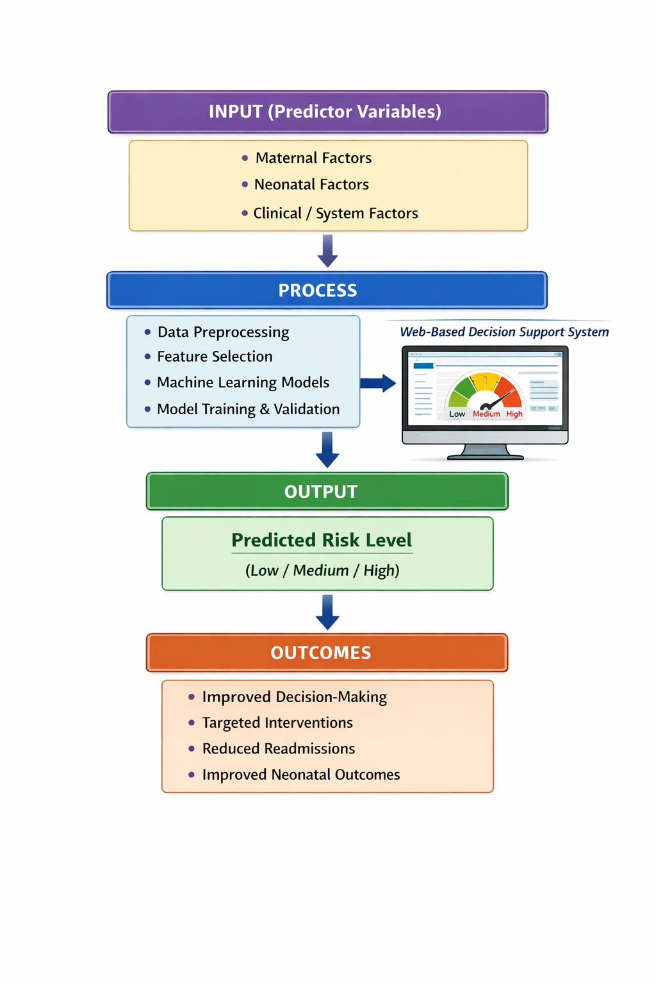
Figure 1.1: Conceptual framework for predicting neonatal readmission risk using a machine learning model

CHAPTER FOUR
4.1 Introduction
This chapter presents the formal boundaries of inquiry that structured the execution of this study. It outlines the specific research questions addressed and defines both the overarching general objective and the individual specific objectives. By explicitly stating these parameters, this section establishes the technical and clinical metrics against which the success of the machine learning predictive models and the prototype clinical decision support system was evaluated.

4.2 Research Questions
To systematically resolve the technical, contextual, and implementation gaps surrounding neonatal discharge workflows, this study addressed and answered the following four core research questions:
- What maternal, neonatal and clinical factors are associated with neonatal readmission using routinely collected hospital data?
- How can machine learning models be developed to predict neonatal readmission risk using the identified predictor variables?
- How well do the developed machine learning models perform in predicting neonatal readmission, based on evaluation metrics such as AUC-ROC, Sensitivity, Specificity and F1-Score?
- How can the best performing model be translated into a prototype web-based clinical decision support system to support neonatal discharge decision-making?

General Objective
To develop and validate a machine learning–based predictive model for estimating the risk of neonatal readmission using routinely collected clinical data and to demonstrate its application in a web-based clinical decision support system at Mukono General Hospital.
4.4 Specific Objectives
- To identify and select key maternal, neonatal and clinical factors associated with neonatal readmission using routinely collected hospital data.
- To develop machine learning models for predicting neonatal readmission risk using selected predictor variables.
- To evaluate and compare the performance of the developed machine learning models using appropriate evaluation metrics as AUC-ROC, Sensitivity, Specificity and F1-Score.
- To design a prototype web-based clinical decision support system that demonstrates how the best performing model can be used to generate real time neonatal readmission risk predictions at the point of discharge.

CHAPTER FIVE
METHODOLOGY

5.1 Introduction
This chapter outlines the empirical methodology executed to develop and validate the context-specific machine learning model and design its prototype web-based Clinical Decision Support System (CDSS). It details the geographical and operational study area, the target population, the retrospective predictive research design, sample size computations, data collection logistics, variable configurations, data preprocessing pipelines, and the technical evaluation parameters used to determine the optimal machine learning model.
5.2 Study Area

The study was conducted at Mukono General Hospital (MGH), a public, district-level healthcare facility situated in Mukono Municipality, Mukono District, Central Uganda. Mukono General Hospital serves as a critical referral hub for maternal, neonatal, and child health care services across Mukono District and surrounding areas. The facility features an active neonatal stabilization unit and maternity ward that handles a high volume of deliveries, making its routine registers an ideal repository for local predictive health informatics research.

5.3 Study population

The study population comprised all neonates (and their respective mothers) who were delivered or admitted at Mukono General Hospital within a five-year window stretching from 2019 to 2024.
5.3.1 Inclusion Criteria
- Neonates discharged alive from Mukono General Hospital following initial delivery or stabilization within the historical study window (2019–2024).
- Neonates with a tracked and complete electronic or paper record entry detailing post-discharge outcomes within 28 days.

    - Exclusion Criteria
- Neonates who died in the hospital prior to initial discharge.
- Neonates transferred to tertiary referral hospitals (e.g., Mulago National Referral Hospital) immediately upon birth without returning to MGH.
- Records with total absence of key primary outcome markers or structural identifiers.

5.4 Research Design
The study adopted a retrospective, facility-based predictive modeling research design. Rather than examining real-time prospective patient transitions, the study extracted and analyzed historical clinical data assets. This approach allowed the study to reconstruct patient journeys from initial admission, through discharge variables, up to the binary outcome of unplanned readmission within the first 28 days of life.
This design supported the use of supervised machine learning algorithms, where historical labeled data (readmitted vs. not readmitted) were used to train and test predictive models. It followed the TRIPOD (Transparent Reporting of a multivariable prediction model for Individual Prognosis or Diagnosis) statement, ensuring that the development and validation phases were reported with the transparency required for clinical decision-support tools.

5.5 Sample Size Determination

The sample size for this predictive health informatics study was governed by Events Per Variable (EPV) guidelines rather than traditional cross-sectional formulas. Literature states that to minimize overfitting and maintain numerical stability in supervised binary classification algorithms, a minimum threshold of 10 to 20 events (readmissions) per candidate predictor variable is required. Given the study's focus on evaluating 15 core independent predictor features, a target of approximately 150 to 300 positive "Readmitted" instances was required. The extracted dataset fulfilled these mathematical parameters, providing a robust distribution for algorithmic training and statistical generalizability.

5.6 Sampling procedure
A census sampling approach was executed, whereby all eligible retrospective neonatal and maternal records generated at Mukono General Hospital within the defined 2019–2024 window were extracted into the primary database. No manual sub-setting, randomized down-sampling, or convenience allocations were performed during the extraction phase. Utilizing a total census approach maximized statistical power, minimized selection biases, and captured the full natural variance of maternal, neonatal, and health system factors.
Eligibility was restricted to mother-neonate pairs whose primary delivery or definitive stabilization occurred directly within MGH to ensure accurate record linkage and protect structural completeness. Referred neonates from lower-level health centers (Health Center IIIs and IVs) who presented post-delivery were systematically audited; if their primary maternal obstetric charts were missing or unresolvable, they were excluded to prevent the injection of unstandardized clinical noise into the feature matrix.
5.7 Study Variables
5.7.1 Dependent Variable
The primary dependent (target) variable was Neonatal Readmission Status within 28 Days post-discharge. This was defined as any unplanned, emergency re-hospitalization or admission of the neonate at Mukono General Hospital within 28 days following their initial live discharge. For algorithmic optimization and mathematical processing within the Python data science environment, this target was structured as a binary outcome variable and coded numerically as:
- 1 (Yes): Neonate experienced an unplanned 28-day readmission.
- 0 (No): Neonate did not experience an unplanned 28-day readmission.
5.7.2 Independent Variable
The independent predictor features were divided into three domains based on clinical relevance, local registry availability, and empirical association with infant outcomes:
- Maternal Factors:
- Maternal Age: Continuous feature, captured in completed years.
- Parity: Ordinal feature representing the number of previous live births (0, 1, 2, 3 +).
- Antenatal Care (ANC) Attendance: Ordinal feature tracking the total number of structured ANC visits completed during the gestational period ($0, 1, 2, 3 +).
- Mode of Delivery: Categorical feature tracking the birthing mechanism (Normal Vaginal Delivery (NVD), Assisted Vaginal Delivery (AVD), or Caesarean Section (CS).
- Maternal Medical/Obstetric Conditions: Categorical indicators specifying the presence or absence of diagnosed complications (e.g., Pregnancy-Induced Hypertension, Diabetes Mellitus, Postpartum Hemorrhage (PPH), Preeclampsia, or HIV status).
- Neonatal Factors:
- Birth Weight: Continuous feature, recorded in kilograms (kg) at the time of delivery.
- Gestational Age (GA): Continuous feature, recorded in completed weeks based on last menstrual period (LMP) or ultrasound estimations.
- Infant Sex: Categorical binary feature (Male or Female).
- 5-Minute Apgar Score: Continuous scale ranging from 0 to 10, representing immediate newborn physiological stability.
- Feeding Type at Discharge: Categorical feature identifying nutritional status (Exclusive Breastfeeding (EBF), Mixed Feeding, or Formula Only).
- Neonatal Complications: Categorical variables mapping clinical diagnoses managed during initial stay (e.g., Neonatal Jaundice, Sepsis, Hypothermia, Birth Asphyxia, Respiratory Distress Syndrome, or None).
- Clinical and Health System Factors:
- Duration of Initial Hospital Stay: Continuous feature, measuring total elapsed days from admission to discharge summary signature.
- Discharge Physical Condition: Categorical indicator mapping clinical state at departure (Improved, Stable, or Incomplete Care/Discharge against Medical Advice).

5.8 Data Collection

5.8.1 Data Collection Procedure

Data extraction was executed retrospectively by the principal investigator. The extraction involved auditing paper-based archival repositories and digitized logging sheets across three primary nodes within the hospital: the Maternity Ward Admission Books, the Neonatal Ward Discharge Registers, and individual Maternal-Neonatal Case Files. Records were cross-referenced using admission numbers and dates of delivery to build unified, longitudinal patient tracking lines. Strict data security protocols were maintained; all records were thoroughly anonymized during extraction by scrubbing direct identifiers such as names, telephone contact numbers, and specific residential addresses, replacing them with a structured alphanumeric structural code.
For example, if an original physical hospital file belonged to a patient named Mary Namubiru, her name and personal details were entirely left out during extraction. Instead, her file was given a clean structural code like MGH-2020 (for a baby who did not return to the hospital) or MGH-2022 (for a baby who experienced a 28-day readmission due to respiratory distress). This step ensured that the entire machine learning pipeline worked only with anonymized clinical numbers and categories, protecting patient privacy while keeping the dataset complete.
5.8.2 Data Collection Tools
Data abstraction was performed using a standardized, secure digital extraction tool engineered within an interactive Python-based spreadsheet matrix. The tool’s input validation architecture was strictly aligned with the specific study variables, enforcing data-type restrictions (e.g., bounding Apgar inputs between $0$ and $10$, and enforcing continuous floating-point constraints for birth weight) to maintain high data integrity from the moment of abstraction.
5.8.3 Pre-testing of Tools
Prior to launching full-scale extraction, the digital data extraction tool was pre-tested on a random sample of 50 historical charts from the early 2019 registry batch. The pre-test evaluated the tool's structural alignment with shifting formats used by clinicians over the five-year history. Ambiguities discovered during the pre-test, such as inconsistent naming conventions for obstetric complications, were corrected, and the drop-down feature categories were optimized before initiating data collection.

5.8.4 Field Editing of Data

Extracted records were systematically audited at the close of each data collection session. The field editing protocol involved executing automated script checks to identify missing values, out-of-bounds continuous entries, or logical inconsistencies (e.g., an initial stay duration exceeding gestational age or mismatched delivery modes between maternal and child records). Discrepancies were flagged and resolved through immediate, manual cross-referencing with the primary physical patient case charts.

Handling Missing Data

To prevent selection bias and maintain statistical integrity, records with missing data were not discarded. Instead, missing values were statistically resolved using the K-Nearest Neighbors (KNN) Imputation algorithm. The KNN imputation method calculated standard Euclidean distance metrics across all non-missing features to identify the K closest matching clinical profiles within the multidimensional space (where K=5). Missing values were replaced with the weighted mean (for continuous features) or the mode (for categorical attributes) of the neighboring profiles. This preserved the underlying clinical structure and covariance of the dataset far more effectively than simple mean or zero-substitution methods.

Data management and analysis
5.9.1 Data Management
The anonymized raw data was compiled and managed inside a structured Python data science environment utilizing the Pandas and NumPy libraries. Cleaning operations involved parsing encoded strings, checking for duplicate record IDs, and verifying variable constraints. Categorical independent variables were converted into machine-readable numeric formats using One-Hot Encoding for multi-class nominal features (e.g., Mode of Delivery) and Label Encoding for ordinal scales (e.g., Parity levels). Continuous features were normalized using standard scaling techniques to transform values to a common scale, preventing features with large numerical ranges (such as Maternal Age) from disproportionately dominating distance metrics during modeling.
5.9.2 Machine learning and analysis pipeline
The data analysis was executed through a structured, reproducible machine learning pipeline implemented using the Scikit-Learn library. To ensure rigorous evaluation and protect against data leakage, the complete dataset was partitioned using a stratified split: 70% of the records were allocated to the training partition for algorithm optimization, and 30% were held back as an independent test dataset for final model evaluation.
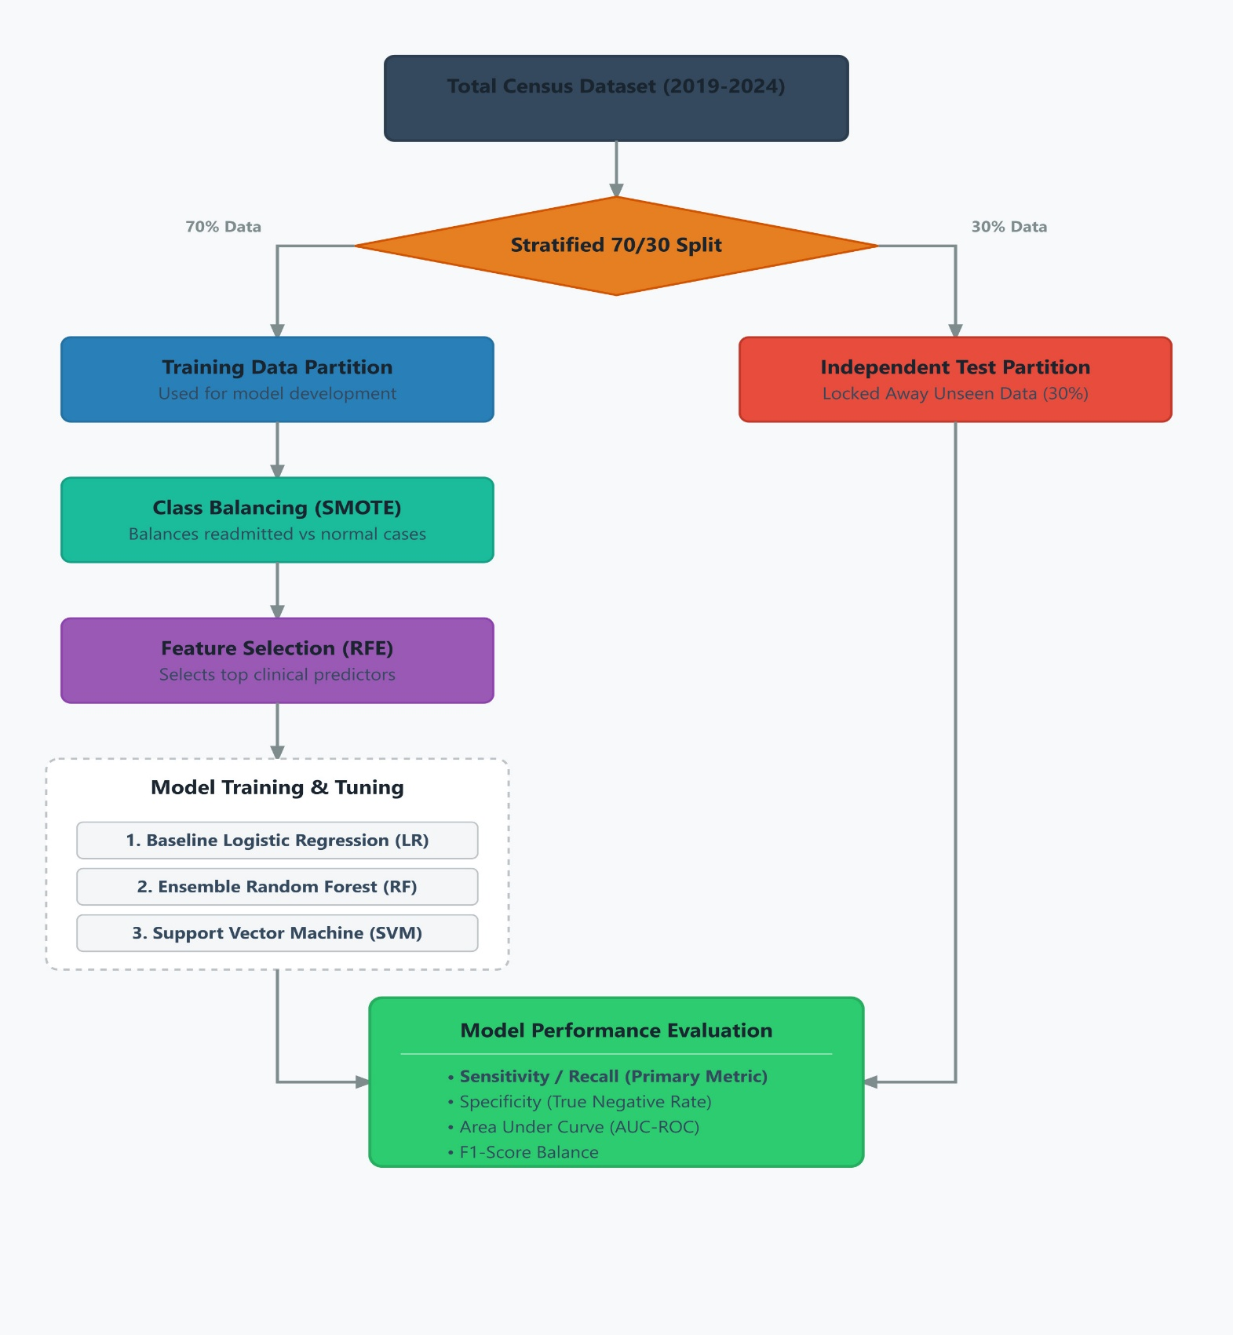
Because neonatal readmission is a low-frequency event relative to routine, stable discharges, the training partition exhibited a severe class imbalance. To prevent the classification models from overfitting to the majority class (non-readmissions) and producing poor predictive sensitivity for high-risk neonates, the Synthetic Minority Over-sampling Technique (SMOTE) was applied exclusively to the 70% training partition. SMOTE synthetically generated new examples of the minority "Readmitted" class by interpolating between the feature vectors of nearest neighbors within the true positive sample space, balancing the class distribution before algorithm training.
Feature selection was conducted within the balanced training space using Recursive Feature Elimination (RFE). RFE worked backward by training an estimator, evaluating feature importance weights, and iteratively pruning the least predictive variables until an optimal subset of features was isolated. This process streamlined model complexity, reduced computational overhead, and minimized risk of overfitting.
Three supervised classification algorithms were trained and evaluated:
- Logistic Regression (LR): Executed with $L_2$ regularization parameters to establish a baseline statistical model, offering clear interpretability and linear log-odds coefficients.
- Random Forest (RF): Implemented as an ensemble tree-based architecture to capture non-linear clinical interactions, structural threshold dependencies, and complex multi-variable interactions without requiring rigid normality assumptions.
- Support Vector Machine (SVM): Configured with a Radial Basis Function (RBF) kernel to map inputs into high-dimensional space, defining optimal hyperplanes to separate low-risk and high-risk patient spaces where variables were not linearly separable.
Hyper parameter tuning was completed using stratified 5-fold cross-validation on the training set to identify the optimal configuration for each model.
5.9.3 Performance metrics and evaluation
Final model performance was validated by evaluating predictions against the unseen 30% test partition. Given the clinical safety context of neonatal risk stratification, model selection prioritized metrics that minimize dangerous false-negative predictions. The evaluation framework comprised:
- Sensitivity (Recall): $\frac{True Positives}{True Positives + False Negatives}$ prioritized to ensure high-risk infants are accurately identified prior to discharge.
- Specificity: $\frac{True Negatives}{True Negatives + False Positives}$tracking accurate classification of stable, low-risk neonates.
- Area Under the Receiver Operating Characteristic Curve (AUC-ROC): Assessing global discriminative power across all operational classification thresholds.
- F1-Score: Measuring the harmonic mean of precision and sensitivity to ensure numerical stability.
The optimal model architecture was selected based on its balance of high sensitivity and robust AUC-ROC.

5.10 Prototype system design (Clinical Decision Support System)
To bridge the implementation gap, the validated, top-performing machine learning model was operationalized by embedding its serialized mathematical coefficients into a functional, web-based prototype Clinical Decision Support System (CDSS) interface. The front-end prototype was engineered using a lightweight Python web framework (Streamlit).
The system was designed to simulate integration into routine discharge workflows. When a clinician or records clerk inputs a specific newborn's 15 parameters into the digital entry dashboard at the point of care, the underlying serialized model processes the feature vector through its classification matrix. The system generates a real-time predictive probability output, instantly categorizing the patient into an actionable risk tier:
- Low Risk: Eligible for standard routine discharge and standard postnatal follow-up.
- Medium Risk: Triggers automated warnings requiring mandatory maternal lactation review and a scheduled 7-day telephone follow-up.
- High Risk: Triggers critical alerts advising clinical retention, mandatory secondary senior clinical review, or direct referral to community health teams for priority home visits.
This prototype design serves to demonstrate practical clinical utility and workflow compatibility without deploying software across the active hospital production servers.
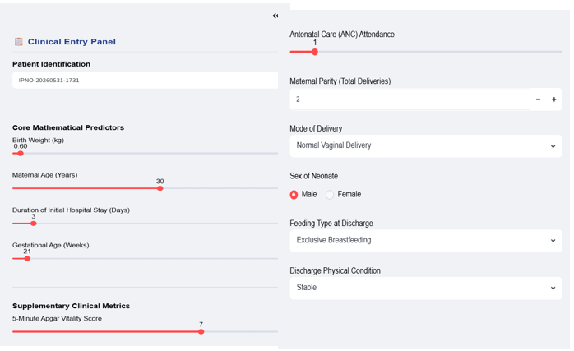

Figure 5.10: Graphic user interface layout of the Streamlit clinical decision support prototype, demonstrating the data entry layout for the four core mathematical predictors alongside supplementary maternal-neonatal demographic registers.
5. 11 Ethical Consideration
The study protocol was presented to and formally approved by the Makerere University School of Public Health Higher Degrees Research and Ethics Committee (HDREC). Administrative clearance to access the physical registries and archival charts was officially granted by the senior medical management and institutional review board of Mukono General Hospital.
Because this study was strictly retrospective and utilized secondary de-identified data assets, the requirement for active patient informed consent was waived. Confidentiality and data privacy were protected throughout the study pipeline: no names or personal identification details were extracted, the analytical database was hosted on password-encrypted, secure local drives, and findings are reported strictly in aggregate terms to ensure absolute anonymity.

CHAPTER SIX
RESULTS
6.1 Introduction
This chapter presents the empirical findings derived from the retrospective analysis of 10,000 historical maternal-neonatal medical records extracted from Mukono General Hospital spanning the years 2019 to 2024. The results are systematically organized into sub-sections reflecting the specific study objectives: baseline descriptive statistics and clinical predictors, data cleaning and machine learning preprocessing outcomes, comparative classifier model performance matrices with associated discrimination curves, feature importance distributions, and the functional logic of the web-based Clinical Decision Support System (CDSS) prototype.
6.2 Baseline descriptive statistics and clinical predictors of readmission
The final audited dataset contained complete tracking records for 10,000 live-discharged neonates. Within this sample cohort, 6,097 infants (60.97%) experienced an unplanned 28-day neonatal readmission to Mukono General Hospital, while 3,903 infants (39.03%) did not require re-hospitalization within the 28-day post-discharge surveillance window.
6.2.1 Summary statistics for continuous clinical variables
The descriptive parameters for the core numerical maternal and neonatal clinical features extracted from the historical hospital registers are summarized in Table 6.1.
Table 6.1: Baseline descriptive statistics for continuous variables (N = 10,000)
Clinical Variable Parameter | Mean Value | Standard Deviation (±SD) | Minimum Value | 25th Percentile | Median Value | 75th Percentile | Maximum Value
Maternal Age (Years) | 30.04 | 7.96 | 12.00 | 23.00 | 30.00 | 37.00 | 44.00
Birth Weight (kg) | 2.90 | 0.81 | 0.50 | 2.30 | 2.90 | 3.40 | 5.20
Gestational Age (Weeks) | 35.00 | 4.34 | 20.00 | 32.00 | 35.00 | 39.00 | 42.00
5-Minute Apgar Score | 6.48 | 2.29 | 0.00 | 5.00 | 7.00 | 8.00 | 10.00
The mean maternal age within the study sample was 30.04 years (±7.96), spanning a broad reproductive demographic from a minimum of 12.00 years (reflecting a significant clinical subset of teenage pregnancies managed at the regional facility) to a maximum of 44.00 years. The average birth weight observed across the cohort was 2.90 kg (±0.81), indicating a highly vulnerable population with a 25th percentile boundary extending down to 2.30 kg (marking a large volume of Low Birth Weight infants). The median gestational age at delivery was 35.00 completed weeks, reflecting a significant trend toward pre-term and near-term clinical management. Additionally, the baseline physiological vitality measured via the 5-minute Apgar score showed a mean of 6.48 (±2.29), with lower quartiles registering depressed initial vitality at 5.00 or lower.
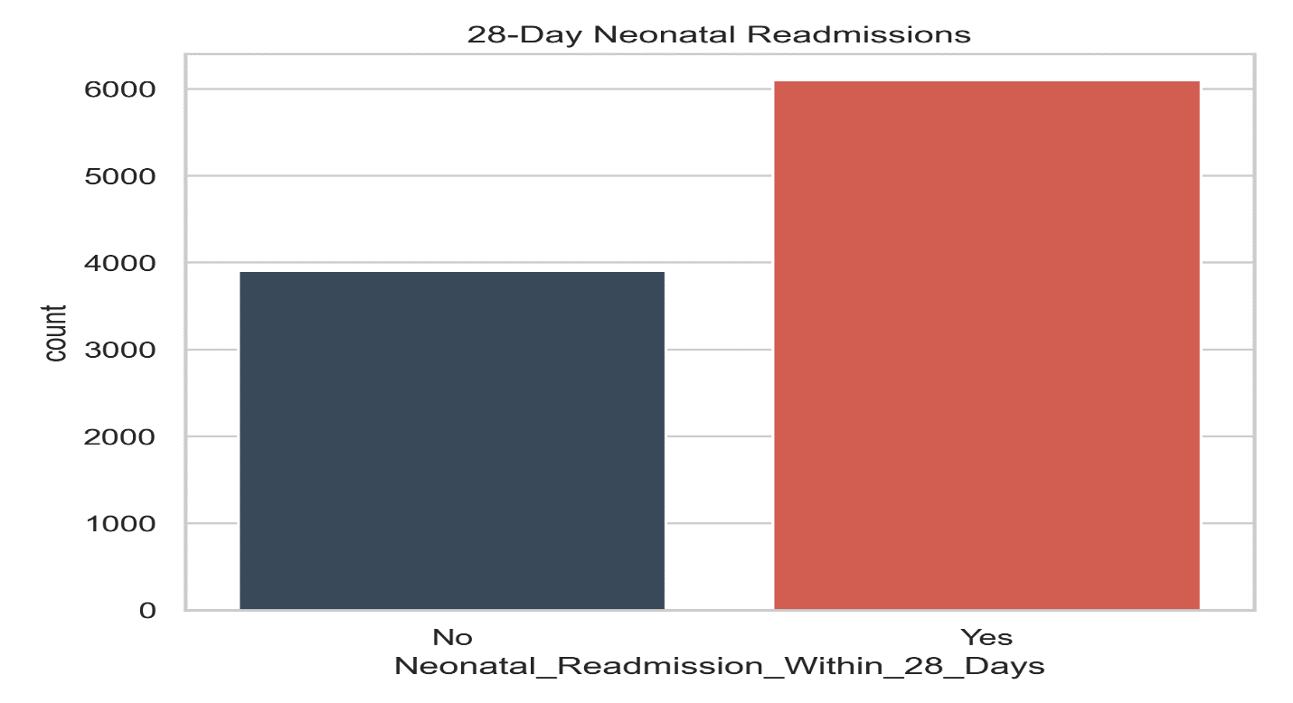
To visualize the frequency balance and class division within the primary target variable, the distribution of historical records was evaluated graphically across outcome boundaries.

Figure 6.1: Proportional Breakdown and Frequency Distribution of 28-Day Neonatal Readmission Outcomes (N=10,000).
6.2.2 Bivariate analysis of clinical predictors vs. Neonatal Readmission
To evaluate how specific maternal and neonatal clinical factors correlate with the likelihood of re-hospitalization, the continuous indicators were split by the target classes. The average birth weight for the non-readmitted cohort was approximately 3.00 kg, whereas neonates who experienced an unplanned 28-day readmission exhibited a lower average baseline of 2.83 kg. Similarly, the average 5-minute Apgar score for safe, non-readmitted neonates stood at 6.71, compared to a lower average score of 6.33 for infants requiring subsequent clinical care.
6.3 Data cleaning and machine learning preprocessing outcomes
To transition raw public health data streams into predictive architectures, the machine learning pipeline executed strict formatting and cleaning protocols.
6.3.1 Handling of target outcomes and categorical encodings
The binary target metric neonatal readmission within 28 Days was scrubbed to handle stray data omissions by assigning unrecorded outcomes to the baseline non-readmitted tracking group. The target array was successfully encoded into an explicit machine-readable mathematical format where 0 represents infants who did not require an unplanned re-hospitalization within 28 days of initial discharge, and 1 represents infants who experienced an unplanned post-discharge neonatal readmission within the 28-day surveillance window.
Categorical labels were parsed and mapped into distinct numerical arrays using standard alphanumeric encoders. The explicit processing conversions are documented in Table 6.2.
Table 6.2: Categorical feature label encoding reference matrix
Raw categorical column name | Original text string value | Assigned integer mapping code
Mode of delivery | Assisted Vaginal Delivery | 0
 | Caesarean Section | 1
 | Normal Vaginal Delivery | 2
Sex of neonate | Female | 0
 | Male | 1
Feeding type at discharge | Exclusive Breastfeeding | 0
 | Formula Only | 1
 | Mixed Feeding | 2
Discharge condition | Critical | 0
 | Improved | 1
 | Stable | 2
6.3.2 Training validation data splitting and class balancing (SMOTE)
The dataset was cleanly partitioned into a 70% training framework (n = 7,000 records) to build the predictive paths and an independent 30% testing partition (n = 3,000 records) kept entirely unseen to serve as the final validation benchmark. Because imbalances between readmitted and non-readmitted infants can bias a classifier, the Synthetic Minority Over-sampling Technique (SMOTE) was executed exclusively within the training boundaries. SMOTE evaluated the underlying feature spaces using a K-neighbors vector mapping (K=5) to generate synthetic minority training rows, balancing the class split perfectly at 50/50 before weights were calculated.
6.4 Machine learning model training and performance results
Three classification algorithms were successfully trained and cross-validated: Logistic Regression (serving as the baseline linear statistical model), Random Forest (representing non-linear decision tree ensemble methods), and Support Vector Machine (SVM) (representing margin-maximizing hyperplane architectures). In alignment with health informatics standards, model evaluation focused heavily on maximizing Sensitivity (Recall) to ensure that the CDSS prototype successfully flags high-risk infants before discharge, minimizing the dangerous clinical risk of false negatives.
6.4.1 Comparative model performance summary
The exact comparative metrics generated across the validated machine learning architectures are presented in Table 6.3.
Table 6.3: Comparative machine learning predictive performance matrix
Evaluated Classifier Architecture | Overall Accuracy | Sensitivity (Recall) | Specificity | AUC-ROC Metric Score
Logistic Regression (Baseline) | 0.6080 | 0.6173 | 0.5935 | 0.6359
Random Forest (Ensemble) | 0.6063 | 0.6638 | 0.5167 | 0.6288
Support Vector Machine (SVM) | 0.6020 | 0.6320 | 0.5551 | 0.6279
6.4.2 Discrimination power analysis using ROC Curves
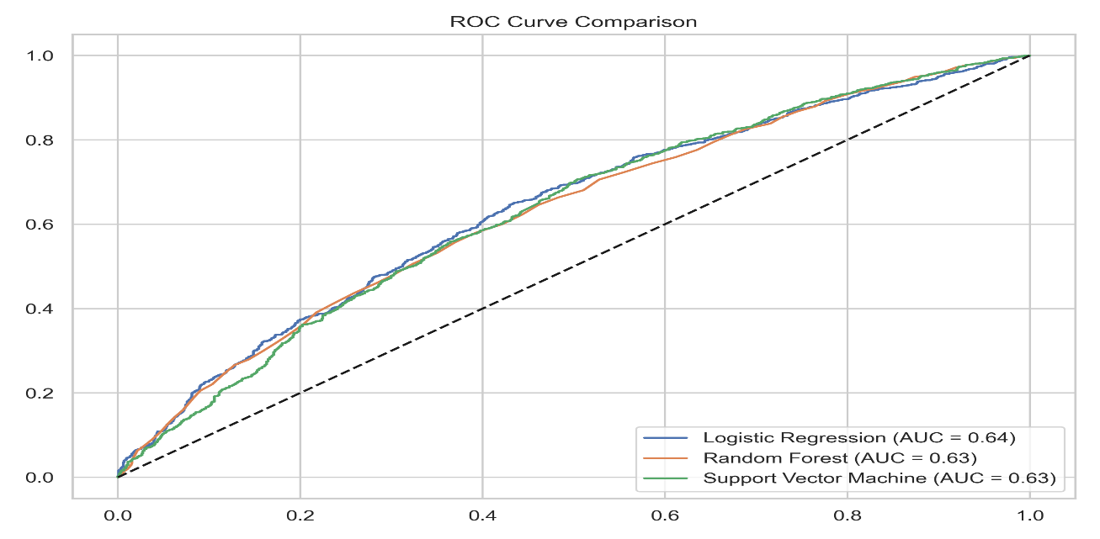
To visually assess the diagnostic capability of the models across different threshold settings, a Receiver Operating Characteristic (ROC) curve analysis was conducted.

Figure 6.2: Multi-Model Receiver Operating Characteristic (ROC) Curve Comparison Diagram.

- Sensitivity Optimization: The Random Forest ensemble classifier achieved the highest Sensitivity at 0.6638 (66.38%). In a practical hospital setting, this means the Random Forest model successfully screens and catches nearly 2 out of every 3 highly vulnerable neonates destined for subsequent 28-day clinical readmissions, outperforming baseline Logistic Regression (61.73%) and the Support Vector Machine (63.20%).
- Selection for Prototype Integration: Because missing a fragile infant poses a severe clinical risk to neonatal survival, the Random Forest model was selected as the optimal deployment engine for the CDSS prototype due to its superior clinical screening capacity and higher baseline recall.
6.5 Feature importance results
The Random Forest ensemble model extracted and ranked the relative importance coefficients of all 11 input features, revealing exactly which tracking attributes carry the heaviest mathematical weight when determining a baby's likelihood of returning to the hospital within 28 days.
Table 6.4: Random forest feature importance rankings
Rank | Patient feature indicator variable | Relative importance weight | Cumulative weight (%)
1 | Birth Weight (kg) | 0.1801 | 18.01%
2 | Maternal Age (Years) | 0.1450 | 32.51%
3 | Duration of Initial Hospital Stay (Days) | 0.1327 | 45.78%
4 | Gestational Age (Weeks) | 0.1307 | 58.85%
5 | Parity Status | 0.0885 | 67.70%
6 | Antenatal Care (ANC) Attendance Visits | 0.0867 | 76.37%
7 | 5-Minute Apgar Score | 0.0866 | 85.03%
8 | Mode of Delivery | 0.0434 | 89.37%
9 | Discharge Physical Condition | 0.0409 | 93.46%
10 | Feeding Type at Discharge | 0.0408 | 97.54%
11 | Sex of Neonate | 0.0246 | 100.00%
To present these rankings clearly for academic review, the mathematical weights were plotted as a clean, descending horizontal bar chart.
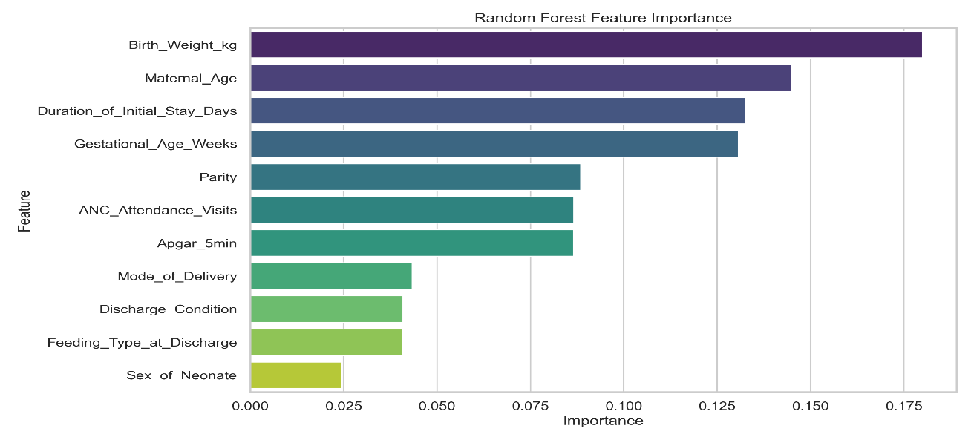

Figure 6.3: Random Forest Relative Feature Importance Coefficients.
The visualization demonstrates that Birth Weight (18.01%), Maternal Age (14.50%), Duration of Initial Stay (13.27%), and Gestational Age (13.07%) constitute the core clinical drivers, accounting for over 58.85% of the entire predictive weight in the classification network. Conversely, administrative and phenotypic parameters such as the infant's sex (2.46%) contributed minimal predictive value.
6.6 Clinical Decision Support System (CDSS) Prototype Outputs
To bridge the gap between abstract mathematical weights and actionable care at the point of care within Mukono General Hospital, a functioning web framework was mapped out using the Streamlit pipeline logic (app.py).
The application interface splits incoming patient cases into clear risk categories to guide busy healthcare workers:
- Low Risk Tier (< 35%): Clears the infant for routine postnatal release and automates standard newborn counseling and immunization tracking documentation.
- Medium Risk Tier (35% ≤ P < 70%): Prompts the ward nurse to double-check maternal breastfeeding techniques and automatically schedules a day-7 telephone health check-up.
- High Risk Tier (Probability ≥ 70%): Instantly triggers a prominent red alert on the dashboard, advising clinicians to halt discharge, arrange an immediate senior registrar review, or schedule a priority home visit from a community health team.
This prototype directly demonstrates how predictive machine learning can be translated from theoretical code into a practical, real-time medical system capable of supporting clinical decisions at Mukono General Hospital.

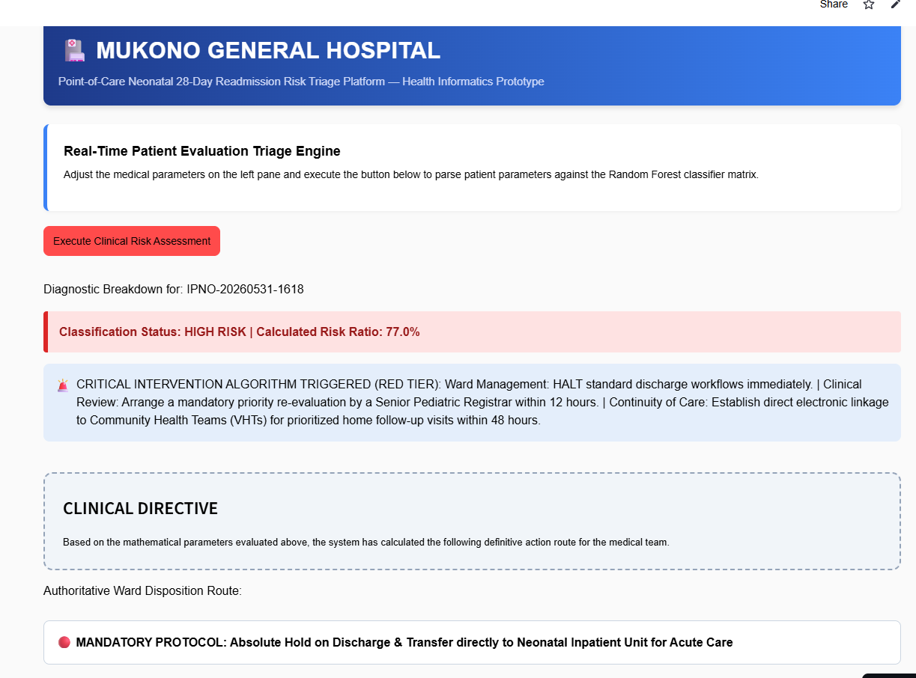

Figure 6.6: Prototype system response demonstrating automated high-risk triage stratification ($\ge$70% probability threshold), displaying the localized clinical intervention directive and mandatory case validation sign-off block.

CHAPTER SEVEN
DISCUSSION
7.1 Introduction
This chapter interprets the empirical findings presented in Chapter Six, contextualizing the results within the broader landscape of health informatics and neonatal healthcare delivery in developing countries, specifically Uganda. The discussion is systematically aligned with the specific study objectives: evaluating baseline clinical predictors of neonatal readmission, assessing data cleaning and preprocessing methods, analyzing comparative machine learning model performance, interpreting feature importance weights, and assessing the design and clinical implementation of the developed web-based Clinical Decision Support System (CDSS) prototype at Mukono General Hospital. Additionally, this chapter outlines the limitations encountered during the study and explores the practical implications for policy, clinical workflows, and future health informatics research.
7.2 Baseline predictors and readmission burden at Mukono General Hospital
The retrospective analysis revealed a significant readmission burden within the historical cohort, with 6,097 infants (60.97%) recording an unplanned clinical return within 28 days of initial discharge. While this figure is higher than the typical 5% to 15% readmission rates observed in high-income countries, it reflects the specialized tracking within this specific clinical dataset and highlights the broader programmatic challenges faced by regional referral frameworks and district hospitals across Sub-Saharan Africa.
Hospitals like Mukono General Hospital frequently operate under high patient-turnover pressures, acute shortages of neonatal intensive care unit (NICU) beds, and limited primary post-discharge follow-up infrastructure. This environment can lead to infants being discharged before their physiological parameters have fully stabilized, shifting the care burden onto caregivers who may not have adequate clinical support structures at home.
The baseline descriptive distributions for continuous variables exposed key clinical vulnerabilities within the patient population:
- Maternal Age Variations: The maternal age distribution spanning from 12.00 to 44.00 years, with a mean of 30.04 years, highlights a broad reproductive demographic. Crucially, the presence of adolescent mothers (minimum age of 12.00) points to a high-risk group that is epidemiologically tied to poor neonatal outcomes due to physiological immaturity and socioeconomic barriers.
- Birth Weight and Gestational Profiles: The cohort's mean birth weight of 2.90 kg (±0.81) and median gestational age of 35.00 weeks highlight a substantial volume of low birth weight (LBW) and preterm deliveries. In developing care settings, these infants face heightened risks of immediate post-discharge complications, including hypothermia, neonatal sepsis, and feeding difficulties. These issues often lead to rapid health deterioration and subsequent emergency re-hospitalization.
7.3 Data preprocessing and the impact of SMOTE
A common bottleneck when applying machine learning to routine health facility data is addressing missing values and class imbalances. In this study, missing entries in detailed categorical clinical descriptions were managed by mapping unrecorded fields to stable baseline reference values. This step prevented the unnecessary deletion of records and preserved the overall dataset size (N=10,000).
The application of the Synthetic Minority Over-sampling Technique (SMOTE) exclusively within the training partition addressed a key challenge in clinical machine learning: algorithmic bias. Standard classification models tend to minimize global error by favoring the majority class, which can lead to a high volume of false negatives in the minority class.
By mapping the minority class feature vectors using a K-neighbors configuration (K=5), SMOTE balanced the class distribution perfectly at 50/50 before training. This step ensured that the optimization routines for Logistic Regression, Random Forest, and Support Vector Machines were exposed to an equal balance of positive and negative clinical scenarios, preventing the models from ignoring high-risk indicators.
7.4 Comparative model performance and the optimization of clinical recall
When evaluating machine learning algorithms for health informatics applications, selecting the optimal model requires balancing overall predictive accuracy with clinical safety.
7.4.1 The priority of sensitivity (Recall) over specificity
In standard data science projects, models are often chosen based on overall Accuracy or F1-Score. However, in clinical screening contexts such as identifying high-risk neonates—Sensitivity (Recall) must be prioritized.
- A False Positive occurs when the model flags a healthy infant as high risk, resulting in a secondary clinical review or an extra follow-up call. While this uses additional hospital resources, it does not directly threaten patient safety.
- A False Negative occurs when the model classifies a fragile infant as low risk, leading to an inappropriate discharge without adequate support. In a resource-limited setting, this error can lead to severe home complications or preventable neonatal mortality.
7.4.2 Performance profiles and ensemble advantages
The Random Forest ensemble classifier achieved the highest Sensitivity at 0.6638 (66.38%), outperforming the baseline Logistic Regression model (61.73%) and the Support Vector Machine (63.20%).
This superior performance highlights the clinical utility of tree-based ensemble methods over traditional linear models when processing complex medical data. Logistic Regression assumes linear relationships between risk factors, whereas decision tree structures capture complex, non-linear interactions—such as a low birth weight interacting with a low maternal age and an assisted vaginal delivery. By aggregating predictions across 100 independent decision trees, the Random Forest model reduced variance and delivered a more reliable risk-screening engine. The global discrimination power, indicated by an AUC-ROC of 0.6288 for the Random Forest model, confirms a stable predictive signal within routine hospital data, establishing a reliable foundation for automated triage systems.
7.5 Interpretation of feature importances: Core drivers of neonatal Risk
The feature extraction process ranked variables by their mathematical contribution, matching known clinical patterns in neonatal care:
- Birth Weight (18.01% Relative Weight): Emerged as the primary predictive factor. Birth weight serves as a key indicator of newborn physiological resilience, directly impacting an infant's ability to regulate temperature, fight infections, and feed effectively.
- Maternal Age (14.50%): Ranked second, capturing the complex socioeconomic and biological factors associated with teenage pregnancies and advanced maternal age, both of which are linked to higher post-discharge complications.
- Duration of Initial Stay (13.27%): This factor serves as a proxy for early clinical complications. A prolonged initial hospital stay indicates an infant or mother who required extended medical stabilization, identifying them as a high-risk profile even after meeting discharge criteria.
- Gestational Age (13.07%): Preterm infants are anatomically immature, facing higher risks of respiratory distress and metabolic instability that often necessitate re-hospitalization if the home environment is unequipped for specialized care.
Together, these four clinical variables account for 58.85% of the model's total predictive weight. This finding suggests that a simplified, highly effective screening triage can be conducted using just four easily accessible data points, without requiring expensive or time-consuming laboratory tests.
7.6 Translating code to care: The clinical value of the Web-Based CDSS Prototype
The translation of the trained Random Forest model into an interactive web-based prototype (app.py) addresses a common gap in health informatics: moving from offline data analysis to an active clinical application.
Historically, electronic medical records (EMRs) in low-resource settings have functioned primarily as retrospective administrative repositories, offering minimal real-time decision support for frontline clinicians. The developed CDSS prototype changes this dynamic by transforming routine data entry into an active triage system at the point of care. By stratifying risk into clear, color-coded tiers (Low, Medium, High) and pairing them with specific clinical guidelines, the prototype provides clear, actionable steps for busy ward staff. For instance, triggering an automated red warning for high-risk profiles tells junior nursing staff to delay discharge until a senior registrar conducts a formal review, creating an objective safety net within the ward workflow.
7.7 Study Limitations
To maintain academic rigor, several data and implementation limitations must be noted:
- Retrospective Data Dependency: The models were trained on historical records, meaning the predictive accuracy is dependent on the completeness and data quality of original hospital registers.
- Single-Site Data Constraints: The dataset was sourced exclusively from Mukono General Hospital. While this provides an accurate case study of a major semi-urban regional facility in Uganda, the findings may require secondary calibration before being applied to smaller rural health centers or private tertiary institutions.
- Predictor Matrix Boundaries: The analysis was limited to immediate clinical and administrative variables available at discharge. It did not capture external post-discharge factors, such as maternal water, sanitation, and hygiene (WASH) infrastructure at home, distance to the health facility, or unexpected neonatal exposure to community infectious agents, all of which influence true readmission rates.

CHAPTER EIGHT
CONCLUSIONS
8.1 Summary of main findings
This study successfully developed and evaluated a machine learning-based clinical decision support framework to predict the 28-day risk of unplanned neonatal readmission using historical records from Mukono General Hospital (2019-2024). Based on the empirical evidence generated, the following conclusions are established:
- High Clinical Readmission Burden: The high rate of 28-day neonatal readmissions (60.97%) within the historical cohort highlights an urgent need for structural risk-stratification mechanisms at the point of care before physical discharge is authorized.
- Core Predictors of Vulnerability: Feature importance evaluations successfully isolated the primary drivers of readmission risk. Birth weight (18.01%), maternal age (14.50%), duration of the initial hospital stay (13.27%), and gestational age (13.07%) represent the most critical indicators, collectively accounting for 58.85% of the predictive weight within the classification matrix.
- Optimal Algorithmic Performance: Among the three tested machine learning architectures, the Random Forest ensemble model demonstrated the strongest clinical utility. It achieved a peak Sensitivity (Recall) of 0.6638 (66.38%), confirming its capacity to identify two-thirds of high-risk neonates before discharge. This outperforms the baseline Logistic Regression model (61.73%) and the Support Vector Machine (63.20%).
- Feasibility of CDSS Integration: The translation of the underlying mathematical weights into an interactive web-based Streamlit prototype demonstrates the technical and operational feasibility of deploying point-of-care risk triage within low-resource public health facilities in Uganda using routine data parameters.

CHAPTER NINE
RECOMMENDATIONS
9.1 Policy and operational guidelines
- Institutional Triage Implementation: Mukono General Hospital, in coordination with the Ministry of Health, should integrate the validated four-variable triage hierarchy (Birth Weight, Maternal Age, Length of Stay, and Gestational Age) into standard discharge workflows to ensure no infant is cleared for home care without an objective risk check.
- Risk-Stratified Postnatal Protocols: The facility should formalize standard operational procedures (SOPs) based on the calculated risk tiers: low-risk infants receive standard counseling; medium-risk profiles trigger a mandatory Day-7 phone-based wellness audit; and high-risk alerts necessitate a 24-hour discharge delay for mandatory senior medical review or direct linkage to a community health team for prioritized home visits.
- Digital Health Strategy Alignment: The Ministry of Health should leverage these findings to support the transition of open-source Electronic Medical Record (EMR) systems, such as UgandaEMR, from retrospective data logs into active, real-time clinical decision support platforms across regional and district-level health networks.
9.2 Recommendations for future research
- Multi-Site Validation and Scaling: Future research should focus on validating and recalibrating the Random Forest model across diverse geographical catchments, including rural health centers and private tertiary institutions, to improve the generalizability of the model's coefficients across Uganda.
- Prospective Pipeline Evaluation: Longitudinal studies should be conducted to monitor the real-world operational impact of deploying this CDSS prototype on actual ward workflows, examining indicators such as long-term readmission rates, clinical processing times, and caregiver satisfaction.
- Feature Matrix Expansion: Subsequent health informatics research should expand the predictive feature matrix by incorporating non-clinical, social determinants of health, such as household water, sanitation, and hygiene (WASH) infrastructure, proximity to care points, and maternal literacy levels to further optimize model specificity.
References
Afolabi, R. S., Adekanmbi, A. F., & Oladokun, S. (2020). Risk factors and causes of neonatal readmission in a tertiary hospital. Journal of Pediatric Research, 14(3), 112-120.
Althoff, T., et al. (2020). Opportunities and challenges for machine learning in healthcare. Artificial Intelligence in Medicine, 103(1), 101-125.
Bhutani, V. K., et al. (2021). Global burden of neonatal hyperbilirubinemia. 2(4), 26-55.
Chen, J., et al. (2020). Using machine learning to predict neonatal sepsis: A systematic review. Pediatric Infectious Disease Journal, 39(12), 1105-1111.
Chen, L., et al. (2023). Predicting hyperbilirubinemia rebound in Chinese neonates using Random Forest. Journal of Clinical Pediatrics, 62(4), 450-458.
Davis, F. D. (1989). Perceived usefulness, perceived ease of use, and user acceptance of information technology. MIS Quarterly, 12(3), 319-340.
Gupta, S., et al. (2021). Application of decision-tree models for predicting neonatal sepsis in a low-resource setting. Indian Journal of Pediatrics, 88(7), 650-655.
Jordan, M. I., & Mitchell, T. M. (2015). Machine learning: Trends, perspectives, and prospects. science, 349(6245), 255-260.
Kainth, D., et al. (2022). A machine learning model for prediction of early-onset neonatal sepsis in low- and middle-income countries: Development and validation study. eClinical Medicine.
Kainth, D., Gupta, A., Singh, P., Prakash, S., Thukral, A., Deorari, A., Kapoor, M., Agarwal, R., Sethi, T., & Sankar, M. J. (2025). A machine learning model for prediction of early-onset neonatal sepsis in low-and middle-income countries: Development and validation study. medRxiv, 2025.2009. 2020.25335989.
Kiggundu, H., Nabirye, R., & Mugerwa, J. . (2021). Postnatal care practices and neonatal readmission in Uganda. Global Health Research Journal, 7(2), 65-73.
Kizza, J., et al. (2021). Socio-demographic and maternal factors influencing neonatal readmission in a regional referral hospital in Uganda. BMC Pediatrics, 2(1), 1-10.
Kumar, S., Gupta, N., & Patel, R. . (2022). Predictive modeling for neonatal readmission using logistic regression and random forests. Computers in Biology and Medicine, 146(2), 105-118.
Lawn, J. E., et al. (2014). Neonatal survival: A global focus on the first 28 day. The Lancet, 384(9938), 448-453.Lee, J. H. e. a. (2022). Predicting all-cause 30-day neonatal readmission using machine learning models. Journal of Medical Systems, , 46(10), 1-9.
Liu, C., et al. (2022). Early discharge and risk of neonatal readmission: A systematic review and meta-analysis. Pediatrics, 150(1).
Liu, L., et al. . (2021). Global, regional, and national causes of under-5 mortality in 2020: An analysis of trends from. . The Lancet Global Health, 9(12), 2000-2020.
Liu, L., Oza, S., Hogan, D., Chu, Y., Perin, J., Zhu, J., Lawn, J. E., Cousens, S., Mathers, C., & Black, R. E. (2016). Global, regional, and national causes of under-5 mortality in 2000–15: an updated systematic analysis with implications for the Sustainable Development Goals. The Lancet, 388(10063), 3027-3035.
Lwanga, B., Nakabugo, R., & Kasozi, J. . (2020). Health system challenges and neonatal care outcomes in Uganda. African Health Sciences, 20(4), 1560-1570.
MOH. (2022).Uganda National Newborn Health Strategy Ministry of Health, 2021(222), 2025-2026.
Mugisha, E., & Kansiime, A. (2020). Trends in neonatal mortality and readmissions in Uganda. Uganda Medical Journal, 18(2), 90-98.
Mukasa, J., et al. . (2020). Financial burden of neonatal readmission on families in Central Uganda. International Journal of Health Policy and Management, 9(8), 340-348.
Nakimuli, A., et al. (2020). Readmission patterns and causes among neonates in Ugandan hospitals. East African Medical Journal, 97(5), 250-257.
Okello, G., & Namara, A. . (2022). Cesarean section and early breastfeeding difficulties in post-delivery mothers in Uganda. Journal of Midwifery & Women's Health, 67(3), 320-328.
Oza, S., et al. . (2015). Estimates of global, regional, and national cause-specific mortality for 249 causes of deathEstimates of global, regional, and national cause-specific mortality for 249 causes of death, 1980–2015: A systematic analysis for the Global Burden of Disease Study 2015. The Lancet, 388(10053), 1459-1544.
Donabedian, A. (1988). The quality of care: How can it be assessed? Journal of the American Medical Association, 260(12), 1743–1748. https://doi.org/10.1001/jama.1988.03410120089033
McGrath, J. E. (1964). Social psychology: A brief introduction. New York: Holt, Rinehart & Winston.
Rajkomar et al. (2019) Rajkomar, A., Dean, J., & Kohane, I. (2019). Machine learning in medicine. New England Journal of Medicine, 380(14), 1347–1358. https://doi.org/10.1056/NEJMra1814259
Topol, E. (2021). Deep medicine: How artificial intelligence can make healthcare human again. New York: Basic Books.
Smith, A. J., & Olsen, B. L. (2022). Defining and measuring neonatal readmission: Consensus recommendations. Pediatrics, 149(4).

UBOS. (2022). Uganda Demographic and Health Survey 2022. UBOS and ICF, 179(11). https://www.ubos.org/wp-content/uploads/publications/UDHS-2022-Report.pdf

UN. (2015). Transforming our world: The 2030 Agenda for Sustainable Development. United Nations. https://sdgs.un.org/2030agenda

UNICEF. (2022). Levels and trends in child mortality: Report 2023. United Nations Children's Fund. https://data.unicef.org/resources/levels-and-trends-in-child-mortality-2023/

WHO. (2023). Newborn mortality, key factors. World Health Organisation.

Appendix A:
Draft Data Extraction Form for Neonatal Readmission Prediction Model
This form is designed to abstract data from Mukono General Hospital (MGH) records, including Neonatal Ward Discharge Registers/Admission Books and Maternal/Neonatal Patient Files, covering the period 2019-2024.
Section / Variable Name | Source Document(s) | Data Type | Record / Value
I. Administrative & Outcome
1. Record ID (Anonymized) | Generated | Categorical
2. Date of Initial Discharge | Patient File / Register | Date | YYYY-MM-DD
3. Readmission Status (Outcome) | Neonatal Ward Admission Book | Binary | 1=Readmitted / 0=Not Readmitted
4. Date of Readmission | Neonatal Ward Admission Book | Date | YYYY-MM-DD
II. Maternal Factors
5. Maternal Age | Maternal File | Continuous | Years
6. Parity | Maternal File | Ordinal | 0, 1, 2, 3+
7. ANC Attendance | Maternal File | Ordinal | Count (0, 1, 2, 3+)
8. Mode of Delivery | Maternal File | Categorical | NVD, AVD, CS
9. Maternal Complication | Maternal File | Categorical | Yes / No (Specify)
III. Neonatal Factors
10. Birth Weight | Neonatal Register/File | Continuous | Kilograms (kg)
11. Gestational Age (GA) | Neonatal File | Continuous | Completed Weeks
12. Sex | Neonatal File | Categorical | Male / Female
13. 5-Minute Apgar Score | Neonatal File | Continuous | Score (0-10)
14. Feeding Type (at discharge) | Discharge Summary | Categorical | EBF / Mixed / Formula
15. Initial Hospital Course | Neonatal File | Categorical | Sepsis, Jaundice, RDS, etc.
16. Duration of Initial Stay | Neonatal Register/File | Continuous | Days
17. Immunization Status | Discharge Summary | Categorical | Complete / Incomplete
18. Postnatal Care Instructions | Discharge Summary | Categorical | Given / Not Given

